WEB APP. SECURITY

Security Breaches are mainly due to:
- Data Theft: Compromising the data security levels
- Buisness Disruption: DDos Attacks, servers go down due to traffic
- Financial Loss: loosing money due to security breach
- Reputation Damage: Damage to image & reputation

Key Security Threats:

- SQL Injection: Manipulating database via inserting malicious code.
- Cross Site Scripting (XSS): Malicious scripts are injected into web pages viewed by users.
- Cross Site Request Forgery: Tricking users to perform unwanted actions.
- Session HiJacking: Stealing users ID to gain unauthorized access.
- Security Misconfiguration: Improper configuration of servers, framework leading to vulnerabilities in the system.

- Network: > 2 computers
- Networking: Transporting and exchanging data between nodes
- Nodes: Connection point in a communication network.

IP Address:
- Unique number assigned to every device connected to internet, varies from 0.0.0.0 to 255.255.255.255.
- This is because IP Address contains 8-Bit grouping in 32-Bytes Address space. (8*32=256)
- A Network inside a network is known as Subnet.

Types of IP Address:

- Public IP address: Directly accessible, available to the internet.
- Private IP Address: Accessible to private network, not accessible to routable network. (166.19.x.x)
- Static IP address: Permanent IP address, they do not change overtime and are consistent. Mostly used by servers.
- Dynamic IP Address: these are temporary assigned address by DSCP servers. (Differentiated Services Code Point Servers). Usually used to check the QoS (Quality of Service) & used by personal devices.
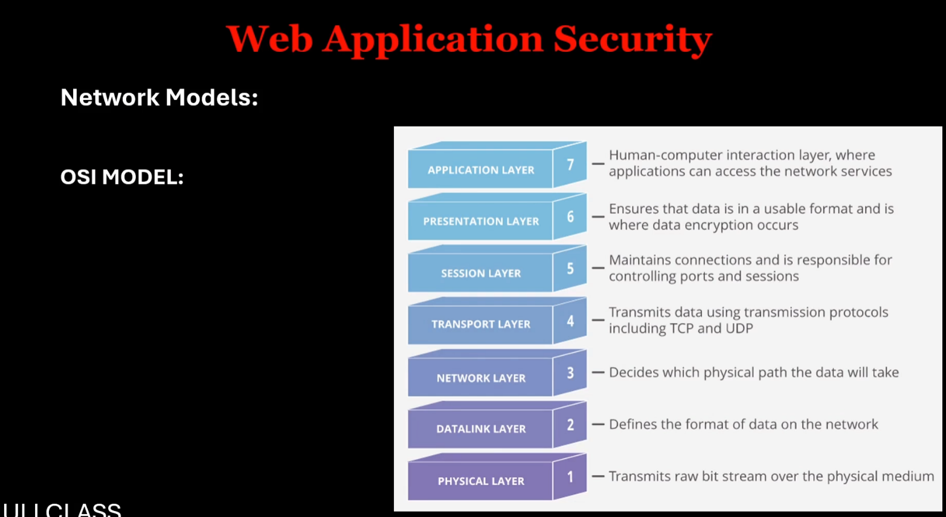

OSI model: Open System Interconnection model
- Layer is to deal with Physical connections like cables, wires, switches, etc.
- Handles data transfer between 2 or more devices under the same network. Also defines format of data.
- Finds the best route for data transfer which is of least hindrance. (GPS of network)
- Follows TCP (Transmission Control Protocol) and (User Datagram Protocol) for data transfer.
- Manages Conversation between the users and network.
- Translate the data into readable, usable format.
- Comp. human interaction layer through which different systems can understand their services.

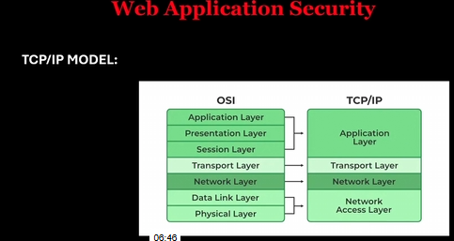
Network Layer is basically internet layer in TCP/IP.

Protocols: Defines how the data is to be transmitted.

- HTTPS (Hyper Text Transfer Protocol Secure):
Uses SSL (Secure Socket Layer) & TLS (Transport Layer Security)
Used for private and secure data transfer in a traffic occupied network also.
Provides Encrypted communication with unique identification.

- SSH: Secure SHell
Securely sends command to computer in an unsecured Network.

- IPsec (Internet Protocol Security):
Secures IP communication by authentication and Encryption of IP packet.

- Firewall:
Acts as barrier between trusted and untrusted networks.

- WAF (Web App. Firewall):
Specifically monitors HTTP traffic and network packet filteration.

- HTTP Fragmentation:
Involves breaking down the HTTP requests/ responses which into smaller pieces (Fragments) are sent separately & reassembled at destination.
Now these WAFs are vulnerable to HTTP because many are not designed to fully reassemble and inspect fragmented traffic.

- Challenges and Concerns:
- Incomplete Inspection.
- Reassembly Challenges/issues
- Evasion Techniques: Like Tiny Fragment Attacks.
- Resource Exhaustion: (Aukat se bahar ka kaam)

Network Security Measures:

- IPS (Intrusion Prevention system): Alerts and prevents admin from intrusion.
- IDS (Intrusion Detection System): Only alerts the admin.
- User human error is significant measure in security due to user education and lack of awareness.
- VPN (Virtual Private Network):
- Creates secure connection between the devices and internet.
- Encryption and authentication (gives us identity of users and devices) are the 2 policies of VPN.

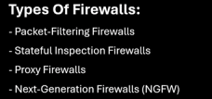
- Examines packet inspecting the source and destination address protocol & port number. Operate at network layer & are simple.
- Tracks connection state, like TCP handshakes (Process to establish reliable and secure connection between 2 devices a 3-way handshake including TCP and 2 devices) Just adds on an extra layer of security.
- Operates in Application layer, acts as intermediate between users and internet. Inspect the content of the traffic and filters unwanted or inappropriate content.
- Combines traditional firewall functions with added features like deep packets, injection, intrusion prevention and application awareness systems providing robust protection.

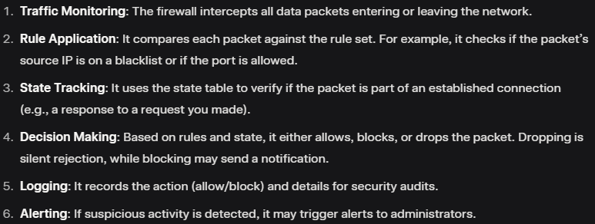
Working of Firewalls:

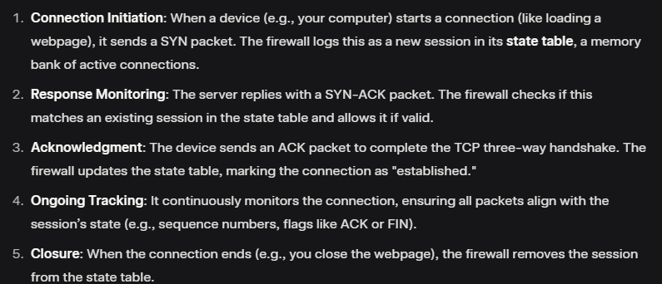

- State Full Inspection Firewall: (above)
Maintains a state table (which tracks the state of active components) and monitors all the active connections.

Working of WAFs:

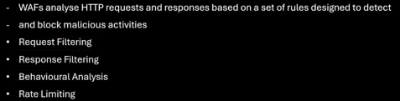

- Request Filtering: for Malicious payload example, they can detect and block the SQL injection attempt by identifying suspicious queries in the requests. Uses Inspection andRule matching methods. (Request is a message sent from a client to server asking for resource like image, webpage, etc.).

- Response Filtering:
Response is reply of request. Request filtering is the process where WAFs control outgoing files and data, preventing leak of sensitive data.

- Behavioural Analysis: Detects anonymous behaviour and abnormal response or requests on servers.

- Rate Limiting: A technique used to limit the no. of requests from a client to prevent overloading leading to DDos Attacks.

Deployment of WAFs:

- Network Based:
- Tested on dedicated hardware or VM, captures all incoming and outgoing HTTP/S traffic at its network perimeter. (With record)
- Inspects the request and responses.
- Blocks SQL injection, XSS, DDoS by above methods.

- Host Based:
- Installed directly on web server or individual host machine.
- It is like a personal bodyguard for a specific server.
- Works closely with OS & application.
- Records security events and triggers alerts for host administrator.

- Cloud Based:
- It is a service provided by cloud provider.
- Ease in deployment, scalable, reduces maintenance.

- DNS: (Domain Name System) It is like phonebook of internet which translates Human readable domain into machine readable IP addresses.

- When a device searches about some domain name eg- Google then a query is generated, if not found then displays as the error is formatted & if is authorized then the given IP address is received by the user.

- NAT: (Network Address Translation) A technique used to map private address to connect the devices through various networks.
- It basically allows multiple devices to get connected on a local network and then share a single public IP address.
- BGP: Used to exchange routing & configures reachability information between autonomous systems on internet.
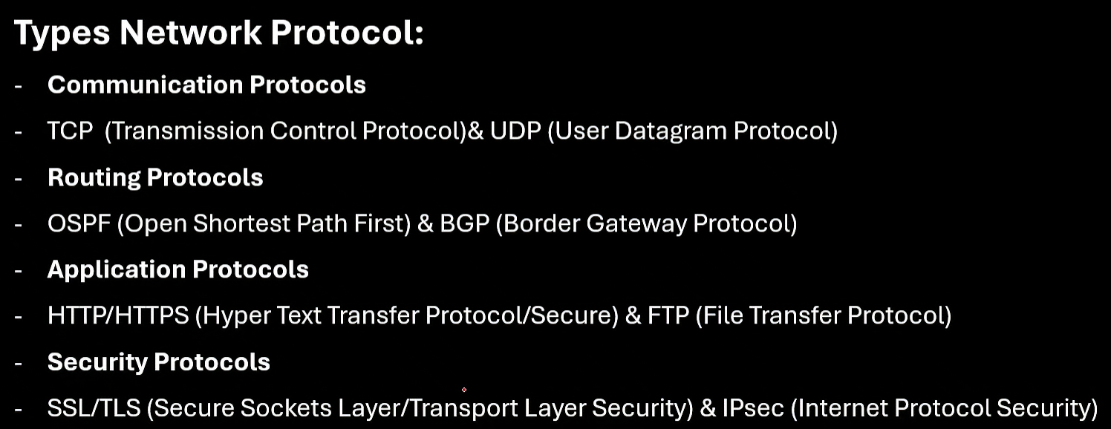
- Ex- when u access a website hosted in another country, BGP determines the best route through multiple ISPs to deliever your request response.

- CIA: Confidentiality, Integrity & Availability.
- AAA Framework:
- Authentication: Verifies identity of user/system
- Authorization: Benefit of permission to access for data.
- Accounting: Creates a log of user’s action for auditing.

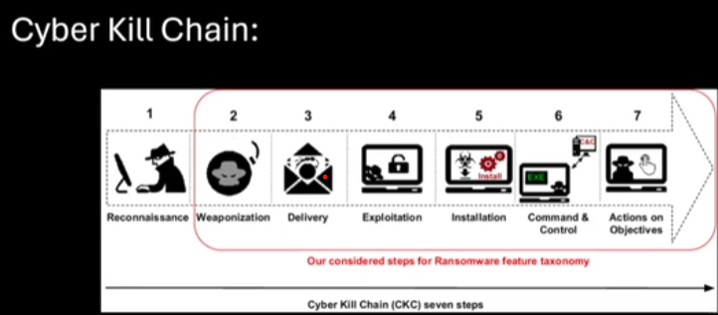
- Reconnaissance: Gathers info about target without being noticed. EX- doing port scan on comp. to identify various ports.
- Passive Reconnaissance: Collecting info about target without directly interacting with it like a spy. (via WHOIS lookups, google…)
- Active Reconnaissance: Directly interacting with target to gather info. by scanning ports, probinmg services & is done via NMAP, Nessus or custom scripts to scan and find vulnerabilities.
- Weaponization: Creating a weapon (ex- botnet, phishing emails) to exploit a vulnerability.
- Delivery: Weapon reaches the targeted server/system/user.
- Exploitation: Exploits the vulnerability and starts the attack. (eg- via .exe file)
- Installation: Installing malware on targeted system, eg- unzipping malicious .exe files or applications.
- C2: Establishing command ovder a channel to control victim’s system.
- Actions: Goal is attack.
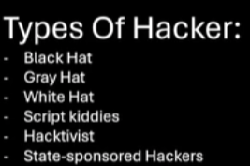
Ports:
- Range from 0 to 65535.
- Registered Ports: 1024 to 19151
- Service Ports: 0 to 1023
- Dynamic Ports: 49152 to 65535 (Temporary ports)

Hacking Tools:

- Nmap: Used for Network Disocvery, security auditing and Pen testing.
- WireShark: Used for network protocol analysis, network task, network flags and network packet.
- Metasploit: Pen testing toolcwith built in experts & payload library.
- Website mirroring tools: Teleport pro, black widow, HTTrack web site copier, page nest, web catcher, archeive.org.

Reconnaissance:

- Foot printing is the 1st step, where info of target is gathered and analysed (sort of detective stuff)
- Tools for foot printing: (OSINT framework, SPYSE, MALTEGO, SHODAN, THE HARVESTER, exploit .TVB (like torrent), Burp-Suite, firebug, zproxy)
- Who is Lookup: provides the domain name registrations details like date, contact info, owner details.
- DNS Reconnaissance: used to record DNS, Domain records & IP address (ex- via https://www.nslookup.io/)
- Google Dorking: A technique which uses advance search operators and queries on google to find hidden, specific or sensitive data.
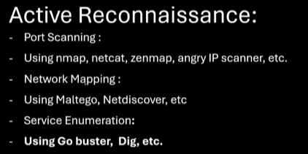
- Ex- Filetype (filetype:pdf), Inurl(inurl:login), Intext(intext: “password”), Intitle (‘intitle: “index of” [optional terms]’ iss naam ke searches ko restrict karta hai), Link (link: example.com), Site (site.example.com)
- Rules to follow for footprinting: 1) work in legal boundary (2) minimize foot printing (3) Respect Privacy.

Command Injection:
- Direct Command Injection:
Attacker directly injects command into vulnerable application & can directly see the output of the command in response.
- Blind Command Injection:
Attacker injects command directly but does not see the command directly but they infer the result from the behaviour of the app. or system. Here Attacker relays on side channel techniques, therefore here attacker needs to be clever enough to detect changes.
- To avoid this we have ‘Principles of least privileges’:
- Limit user Permissions
- Separate Privileges
- Containment
- Also we have some other practises to avoid it:
- Input Validation
- Use Secure APIs (to use secure language specified functions)
- Apply Least privilege
- Regular Audits
- Educate Developers

Cross- site Scripting: (XSS)
- Stored XSS:
Malicious script is permanently stored on the server & affects the system of all users who view the infected page.
Common targets are User Profiles, Forums, Product Reviews
- Reflected XSS:
Malicious script is embedded in a URL or input and reflected back in the response.
- DOM- Based XSS:
Attack is executed by modifying DOM (Document Object Model) in victim’s browser without any server interaction.
This occurs within the client-side script.

Preventive Measures for XSS:

- Input validation: like checking if input provided infects the page or not if yes then sanitize and validate it.
- Output Encoding: Encode output to ensure that input provided is treated as data not as executable code.
- CSP (Content Security Policy): It is a HTTP header allows you to create an allowlist of sources from which content can be loaded.

Directory/Path Transversal:
- Allows the user to access files and directories that are stored outside the wave root folder.
- By manipulating file paths using (../) sequences or absolute paths, an attacker can read sensitive files like: Configuration files, application source code, database credentias, log files.
- Impacts of Directory Transversal:
- Sensitive Data exposure
- Information Disclosure
- Arbitrary File Access (reading files not accessible to users)
- Principle Of Least Privilege:
- Limit User Permissions
- Isolate Files
- Containment

